**Project Title**

**Team Id: NM2025TMID14188**

**Team Members:**

**Team Leader:**

**Mithun. R**

**Manikandan. L**

**Nithish Kumar. S**

**Santhosh. K**

**Problem Statement: Streamlining Ticket Assignment for Efficient Support Operations.**

**Streamlining Ticket Assignment for Efficient Support**

**Operations**

**Problem Statement:**

The objective of this initiative is to implement an automated system for ticket routing at ABC Corporation, aimed at improving operational efficiency by accurately assigning support tickets to the appropriate teams. This solution aims to reduce delays in issue resolution, enhance customer satisfaction, and optimize resource utilization within the support department.

**Objective:**

**1.Define User Roles Clearly:** Establish distinct roles for Alice (Project Manager) and Bob (Team Member) to ensure clarity in responsibilities and access rights within the project management tool.

**2.Streamline Workflow Processes**

* **To implement an automated ticket routing system at ABC Corporation.**
* **To improve operational efficiency by assigning tickets to the right teams.**
* **To reduce delays in issue resolution.**
* **To enhance customer satisfaction through faster responses.**
* **To optimize resource utilization within the support department**

**Skills:**  Users, Groups, Roles, Tables, Access Control List, Flow Designer

**TASK INITIATION**

**Milestone 1 : Users**

# Activity 1: Create Users

1. Open service now
2. Click on All >> search for users
3. Select Users under system security
4. Click on new
5. Fill the following details to create a new user
6. Click on submit

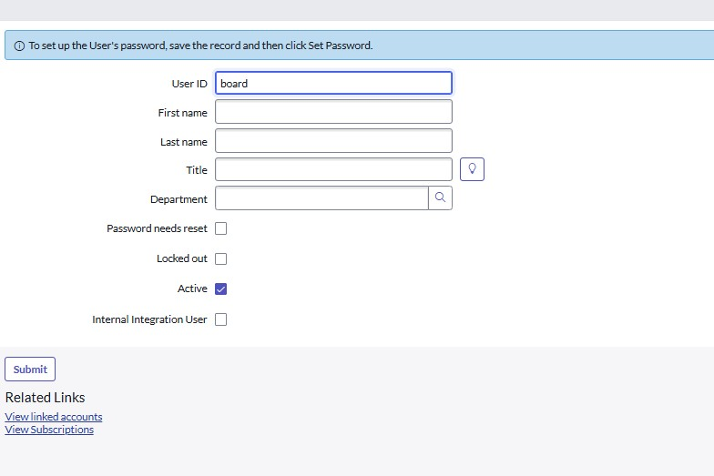

**Create one more user:**

1. Create another user with the following details
2. Click on submit

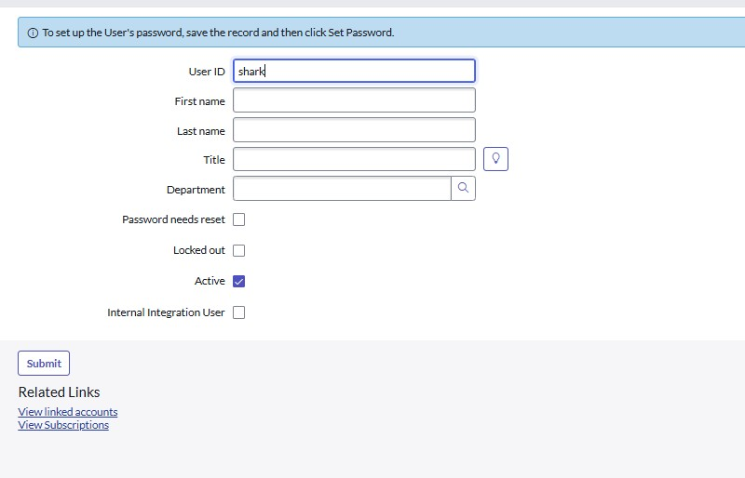

**Milestone 2 : Groups**

# Activity 1: Create Groups

1. Open service now.
2. Click on All >> search for groups
3. Select groups under system security
4. Click on new
5. Fill the following details to create a new group
6. Click on submit

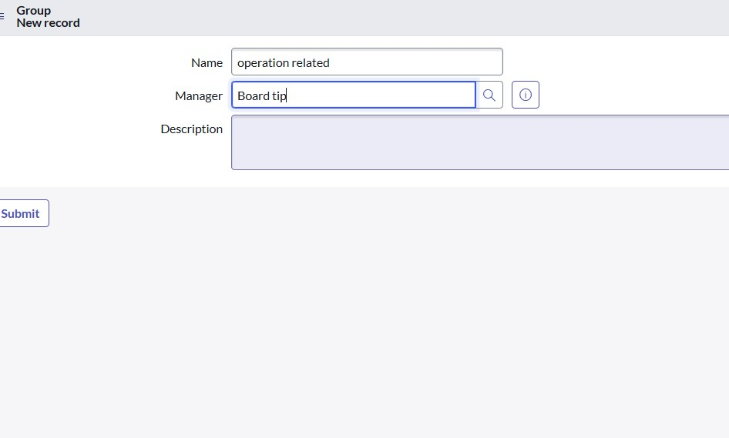

**Milestone 3 : Roles**

# Activity 1: Create roles

1. Open service now.
2. Click on All >> search for roles
3. Select roles under system security
4. Click on new
5. Fill the following details to create a new role
6. Click on submit

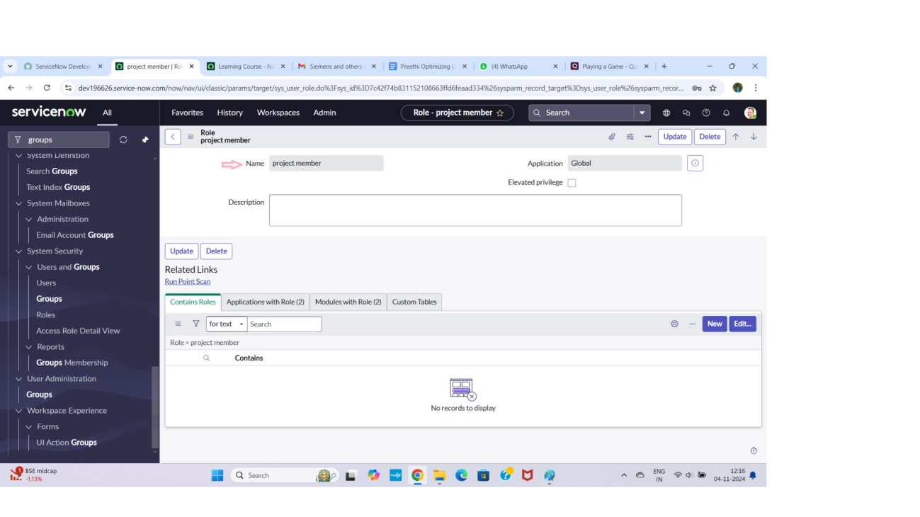

# Milestone 4 : Table Activity 1: Create Table

1. Open service now.
2. Click on All >> search for tables
3. Select tables under system definition
4. Click on new
5. Fill the following details to create a new table Label : operation related
6. Under new menu name : operation related
7. Under table columns give the columns

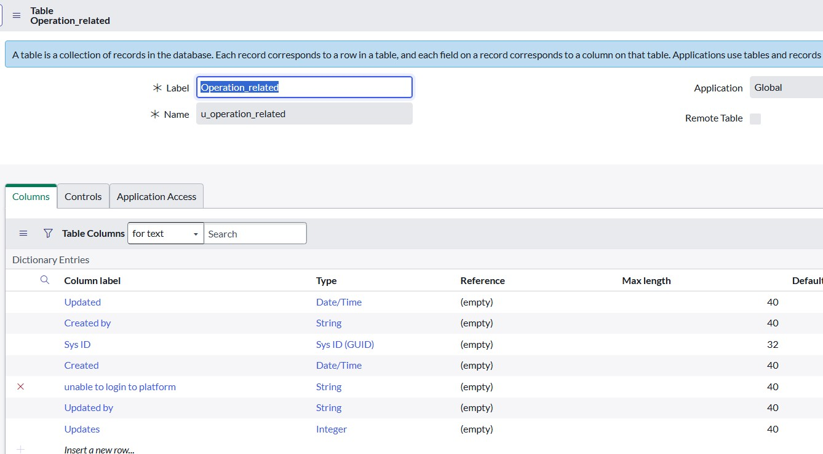

1. Click on submit



**Create one more table:**

9.Create another table as:task table 2 and fill with following details.

10. Click on submit.

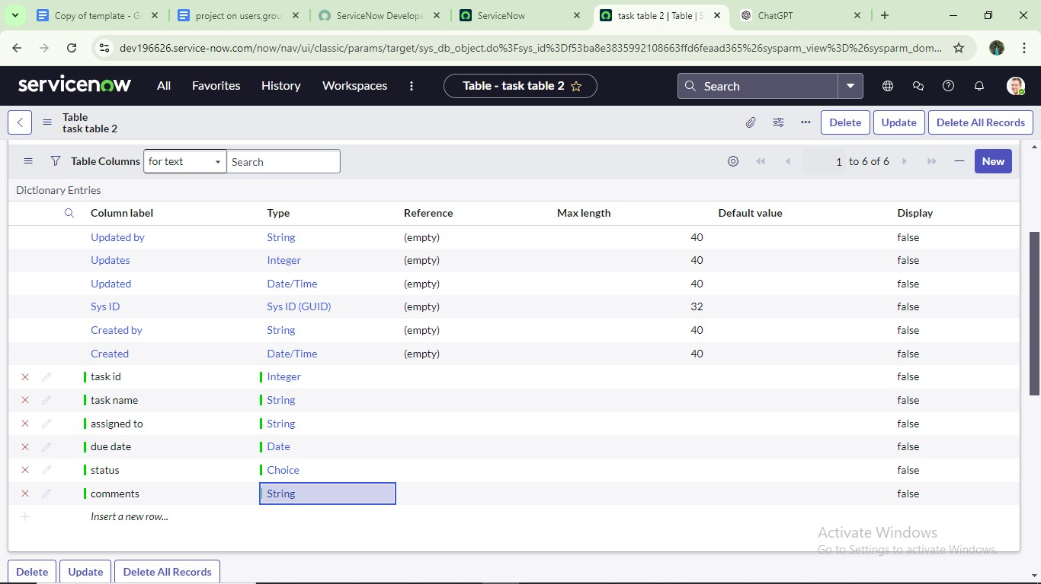

**Milestone 5 : Assign users to groups**

# Activity 1: Assign users to project team group

1.Open service now.

2.Click on All >> search for groups

3.Select tables under system definition

4.Select the operation related group

5.Under group members

6.Click on edit

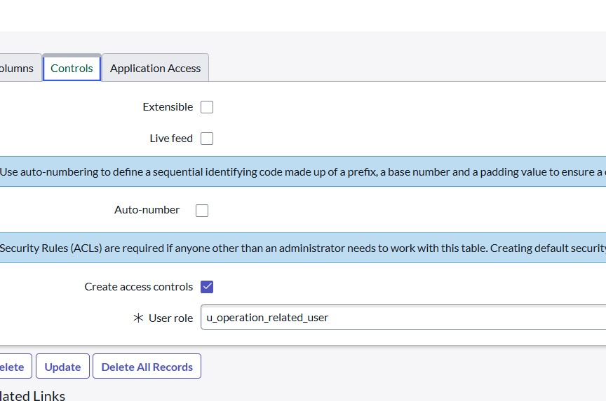

**Milestone 6 : Assign roles to users**

# Activity 1: Assign roles to user

1.Open servicenow.Click on All >> search for user

2.Select tables under system definition

3.Select the project manager user

4.Under project manager

5.Click on edit

6.Select project member and save

7.click on edit add u_ operation_related role

8.click on save and update the form.



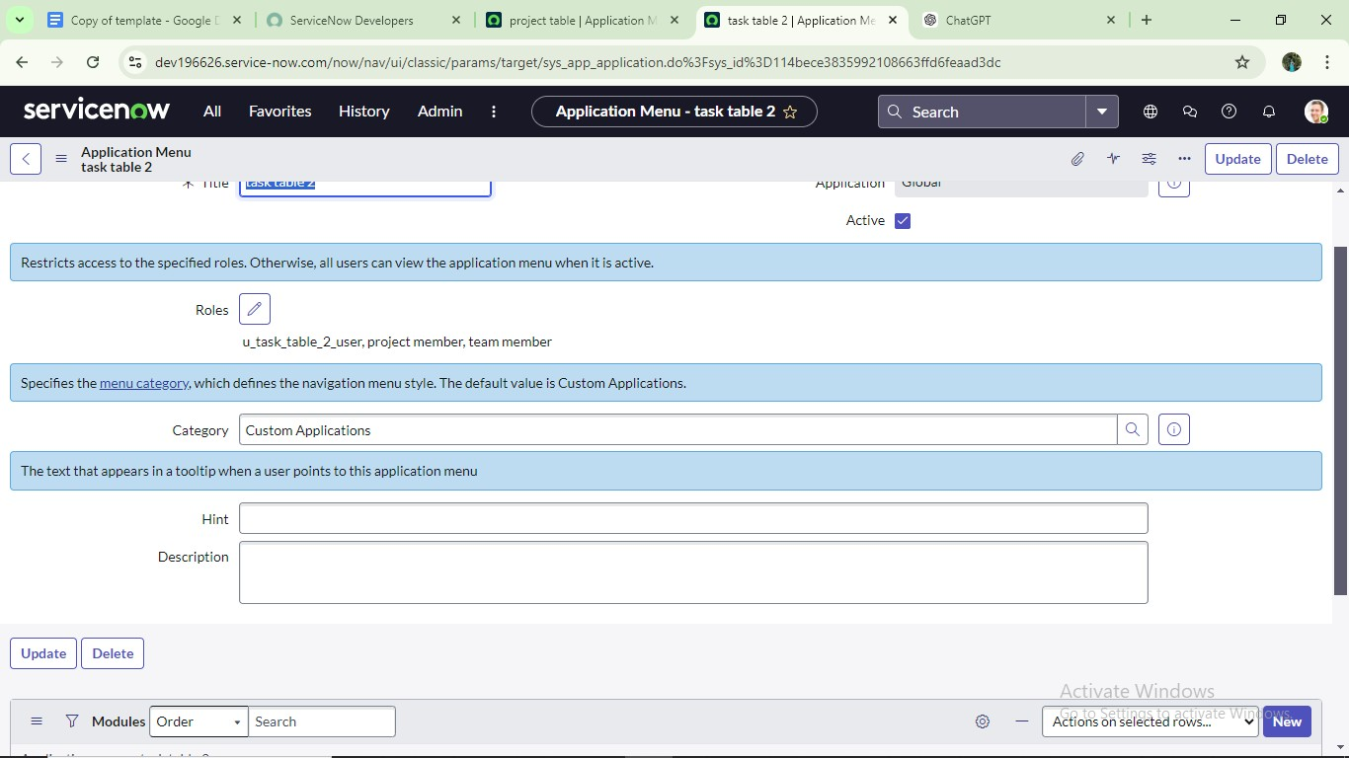

# Milestone 8 :Access control list Activity 1: Create ACL

1. Open service now.
2. Click on All >> search for ACL
3. Select Access Control(ACL) under system security
4. Click on elevate role 5. Click on new

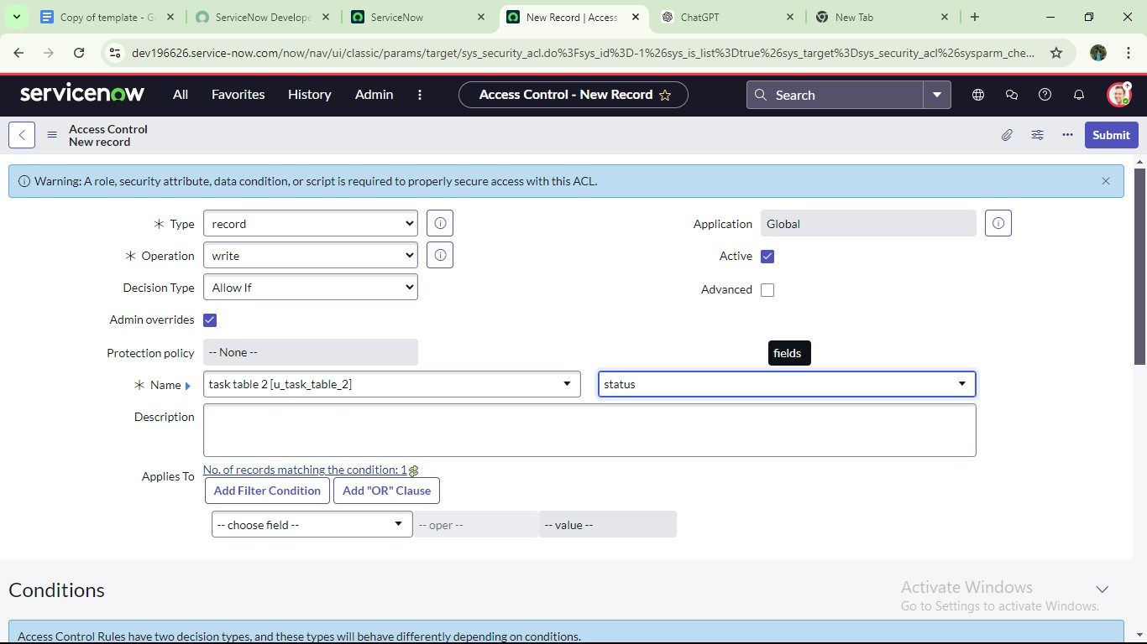

1. Fill the following details to create a new ACL
2. Scroll down under requires role
3. Double click on insert a new row
4. Give task table and team member role
5. Click on submit
6. Similarly create 4 acl for the following fields

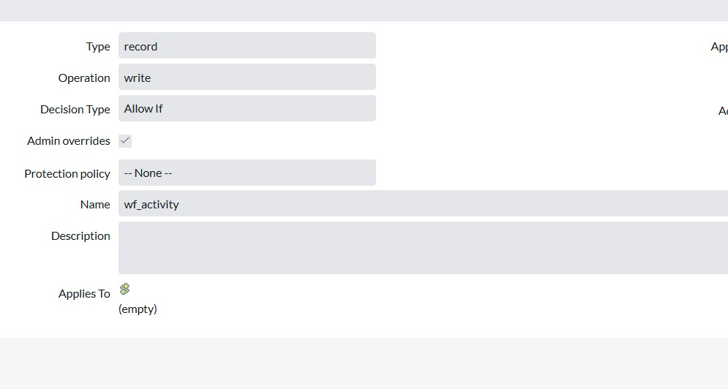

# Milestone 9: Flow

## Activity 1: Create a Flow to Assign operations ticket to group

1. Open service now.
2. Click on All >> search for Flow Designer
3. Click on Flow Designer under Process Automation.
4. After opening Flow Designer Click on new and select Flow.
5. Under Flow properties Give Flow Name as “ Regarding platform table”.
6. Application should be Global.
7. Click build flow.

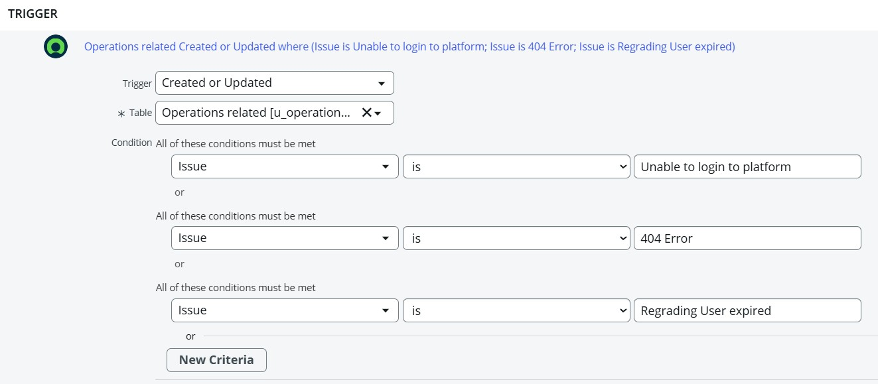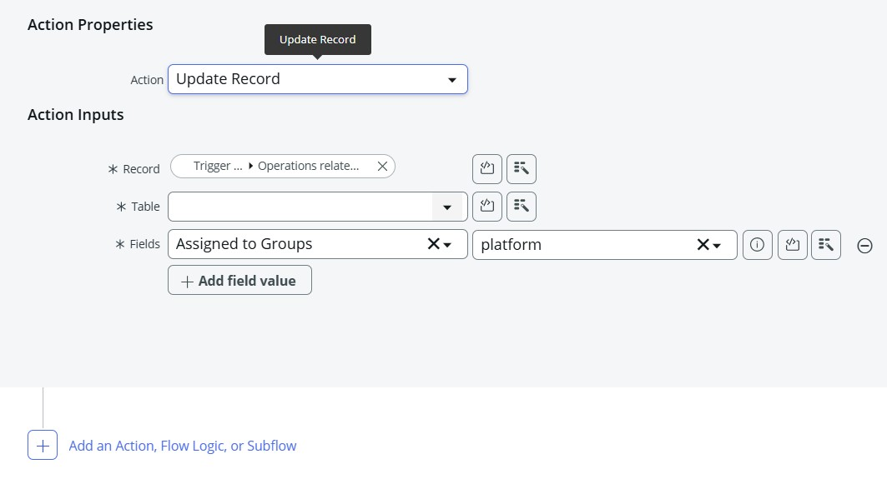

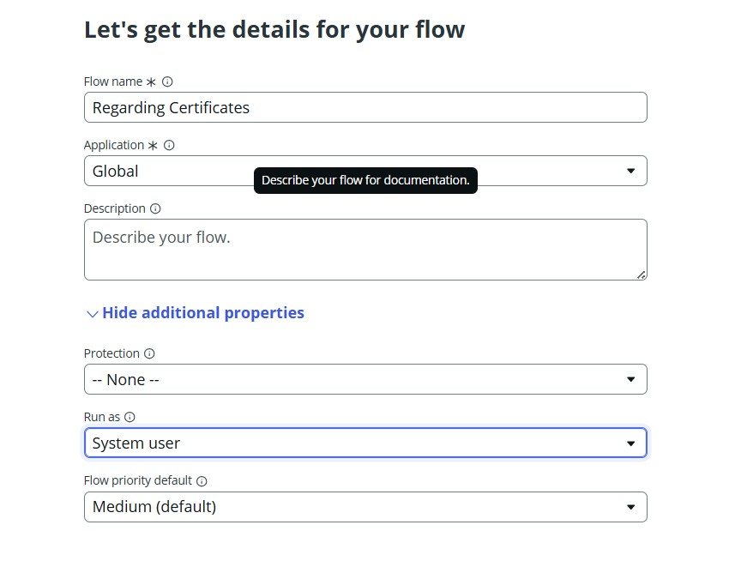

Now click on done, then submit.

CONCLUSION:

The implementation of an automated ticket routing system at ABC

Corporation streamlines support operations by intelligently assigning issues to the right teams. This not only minimizes resolution delays but also improves customer satisfaction and ensures optimal use of resources. Overall, the solution demonstrates how automation can significantly enhance efficiency, accuracy, and service quality within the support department.